Open DoorCounter
A simple way to count visitors to your store
Sponsored by PeopleForBikes Data Suite

What is in the box?
- Camera — A small camera (about the size of a matchbox)
- Cable — A USB cable to power it
- Power adapter — A small wall plug
That's it. There is nothing to install on your computer or phone, no software to log into, and no monthly fee.

What does it do?
The camera mounts above your front door, pointing straight down at the floor. Whenever someone walks underneath, it counts them. Once an hour, it sends the count to us so we can share visitor traffic reports with you.
Your privacy is protected. The camera looks straight down at the top of people's heads — it cannot see faces. No video or photos are ever saved or sent anywhere. Only the count of how many people walked through.

How do I set it up?
The whole process takes about 5 minutes. You will need a stepladder and your store's WiFi password.
Step 1 — Mount the camera above your door
Use the included double-sided tape (or a screw, if you prefer) to stick the camera to the ceiling, directly above where people walk through your front door. The lens should point straight down at the floor. Aim for roughly 7 feet (about 2 meters) above the floor — most ceilings work fine.
Step 2 — Plug it in
Connect the USB cable to the camera and to the wall plug. Plug the wall plug into any standard outlet. The camera will turn on automatically — you will see a small blue light.
Step 3 — Connect it to your WiFi
Take out your phone and open its WiFi settings. You will see a new network called "DoorCounter-Setup". Connect to it. Your phone will automatically open a setup page — enter your store's WiFi name and password, then tap Save.
After about 30 seconds, the red light on the camera will turn off. That means it is connected and counting. You are done!
What do I do day-to-day?
Nothing. The camera works on its own, 24 hours a day. It uses about as much electricity as a nightlight (less than $1 per year), runs cool, and never needs to be touched.
A small light blinks each time someone walks through. You may notice the count happens 3–5 seconds after the person passes — that is normal.

Where can I see the traffic counts?
Your traffic counter will be linked to your PeopleForBikes Data Suite login. You will be able to see foot traffic and bluetooth activity monitoring on the dashboard. https://datasuite.peopleforbikes.org

If something seems wrong
- Blue light stays on — your WiFi password is probably wrong, or the WiFi network is out of range. Reconnect your phone to "DoorCounter-Setup" and re-enter the password.
- No light at all — unplug it for 10 seconds and plug it back in.
- Anything else — please contact us using the information below.

Questions?
We are happy to help. Reach out anytime:
- Email: peter@research.bike
- Project page & source code: https://git.research.bike/Bicycle_Market_Research/DoorCounter

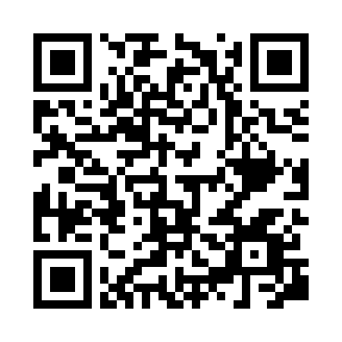

Thank you for participating in our retail traffic study.

